Step 14. Measure Up Validation
Within this section, you will validate that the measurements entered within the last few steps are correct and that the machine checks in properly in multiple different positions when a design is loaded. It is extremely important to confirm that the measure up has been completed correctly as the machine will be inaccurate if anything is amiss.
Validating the measure up involves 9 different steps intended to determine where an error may be present within the measure up. This process will confirm that both 2D and 3D modes will function properly. It is necessary to start validating 2D first.
1. Bucket measure-up and calibration
2. Stick measure-up and calibration
3. Boom measure-up and calibration
4. Body calibration
5. Fixed Sensor initialization & measure-up
6. Auto measure-up and calibration
7. 3D measure-up
8. Site calibration
9. Design
Note: For every step you want to see an accuracy of ± 10mm however ± 20mm is acceptable. If more than ± 20mm difference between positions, re-evaluate the measure up or machine condition.

Step 1: Prove Bucket Measure up and Calibration
This step tests the bucket and dogbone measure up and calibrations. Perform this as the first part of the 2D test and perform it every time a new bucket or attachment is measured up.
1. Using marking paint or similar, mark a point on the ground in front of the
machine.
2. Place the machine into Position 1:
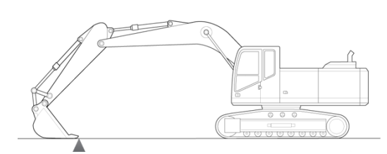
3. Navigate to the Front Linkage Position menu and record the attachment
measurements.
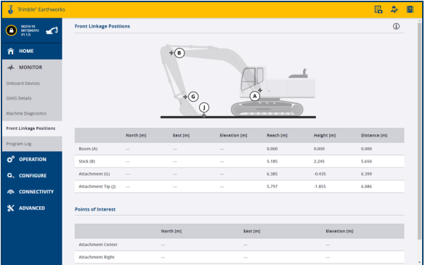
4. Place the machine into Position 2 with the same tooth on the marked point:
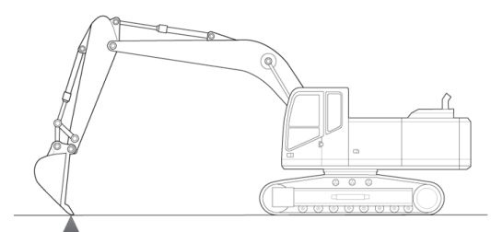
5. Record the Attachment Tip Measurements
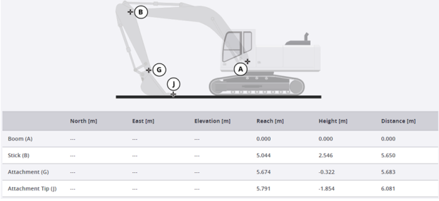
6. Place the machine into Position 3 with the same tooth over the measured point:
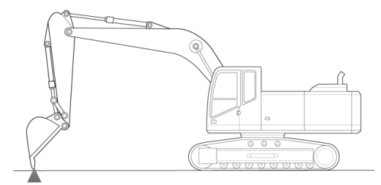
7. Record the Attachment Tip position within the Front Linkage Positions menu
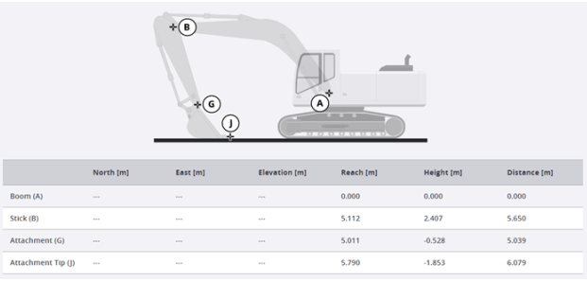
Step 2: Prove Stick Measure Up and Calibration
This step builds on top of the last test and tests the stick measure up and calibrations. This step will utilize the same marked position as step 1.
1. Place the machine back into Position 1:
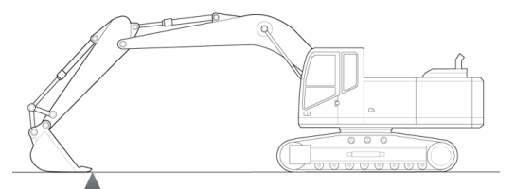
2. Enter the Earthworks App, Select the Start button, and navigate to the Work
Settings menu. Open Measure Mode.
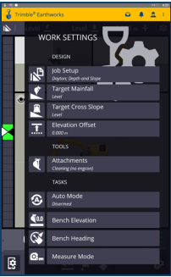
3. The starting position (Position 1) is the initial position of Measure Mode. Select
the Origin button. This test is looking for a position difference to be less than
0.01m (.04ft).
4. Position the machine as the following diagram shows and measure distance
between point J and the marked point on the ground from earlier steps.
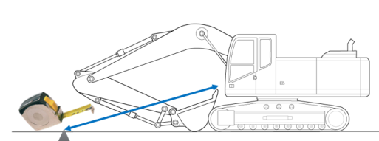
5. Within Measure mode, navigate to point 2 and compare your tape
measurement to the slope distance shown.
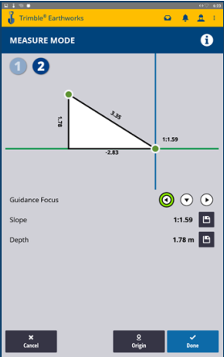
Step 3. Prove Boom Measure up and Calibration
This step builds on top of the last test and validates that the Boom measure up and calibrations are within specs.
This step will utilize the same marked position as step 1.
1. Place the machine back into position 1 from previous steps.
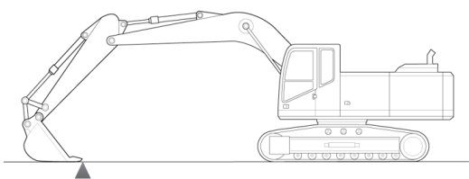
2. Open Measure Mode in the Earthworks App and save this position by selecting
the Origin button.
3. Move the boom into position as shown and take a tape measurement from
Point J to the mark at the origin point.
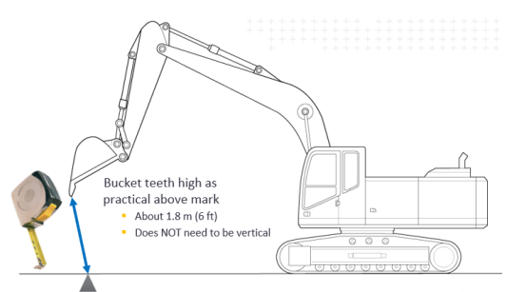
Note: This test requires a measurement while the bucket is in the air. DO NOT stand under the bucket or the front linkage!

4. Navigate to point 2 within the Measure Mode screen and note the Slope
distance. The Slope distance should match the tape measurement taken in step
3.
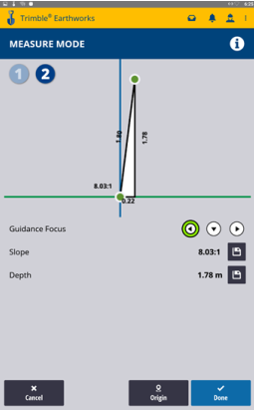
Step 4. Prove Body Calibration
This step Validates the body calibrations. This step has been completed previously during the measure up process however may be best practice to test again. The particular method shown here is different from the one shown before however may be useful. The machine must be on a surface with more than 3.5% (2.0°) slope for this test. A slope of 7% (4°) or greater will produce the most accurate test.
The Body calibration should be within ± 0.10 % however up to ± 0.40 % is acceptable.
1. Align the side of the cab with the tracks and navigate to the machine.
2. Enter the Earthworks App and navigate to the Machine pitch and roll screen.
3. Take note of the Machine’s pitch and roll values.
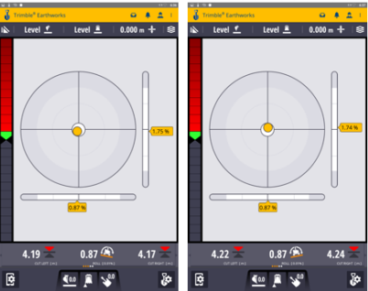
4. Move the machine 180 degrees and align with the initial reference (Side of
track, etc).
5. Ensure that the numbers are opposite to each other. For example, -2° and 2°.
Step 5. Prove Fixed Sensor Initialization
This step Validates the Fixed Sensor Initialization and the measure up positions of the sensors themselves.
1. Touch the machine’s attachment center point (half way between each tip) to the
previously marked position on the ground.
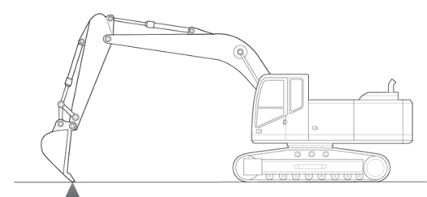
2. Record the attachment tip elevation (J) at this point. This can be accomplished
in the Front Linkage Position screen within the Web Interface.
3. Position the machine so that the attachment and linkages will not contact the
ground when the machine rotates 360 degrees.
4. Note these initial distances:
- Distance A-G
- Distance B-J
- Distance G-F
- Distance A1-A3 (Boom Cylinder Length)
- Distance R-S (Stick Cylinder Length)
- Distance C-F (Attachment Cylinder Length)
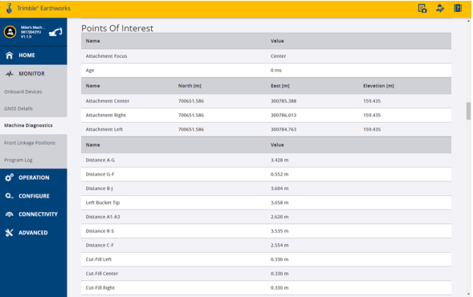
5. Check that the machine is free of obstructions within the swing radius of the machine.
6. Rotate the machine at the highest safe speed while monitoring your surroundings.
7. Observe the distances noted above during:
- The Start of the rotation
- Steady-state of rotation
- The end of rotation
It is desired to see less than ± 40mm (± 0.13ft) of difference between these measurements while moving. It is required to see less than ± 80mm (± 0.26ft).
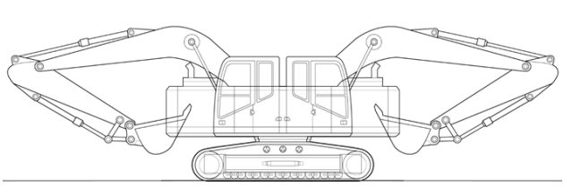
8. Return the attachment center point to the reference point.
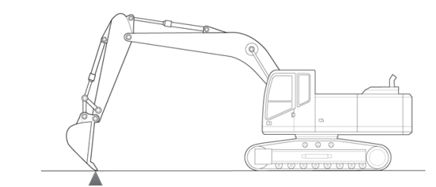
9. Check that there is no noticeable delay in the system reporting the position of the reference point. If there is a delay, the issue relates to the Fixed Sensor Initialization or one of the sensor position measurements.
This section will complete the 2D portion of the measure up validation.
Step 6: Prove Auto Measure up and Calibration
Within this section of the validation, you will be proving that the points measured up for Automatics are within specification. This step requires measuring the front linkage rams to ensure that the lengths shown in Earthworks match reality. This process can be carried out using a tape measure or via UTS utilizing Hexcal.
Method 1 -Tape Measure:
Measure the lengths of the front linkage rams as shown below:
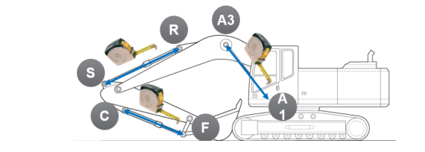
Method 1 -Hexcal and UTS:
Measure the required points, CT1, CT2, A, B, G and the cylinder pins A1, A3, R, S, C and E. Enter this information into Hexcal and compare it to the dimensions given in Earthworks within the Points of Interest screen.
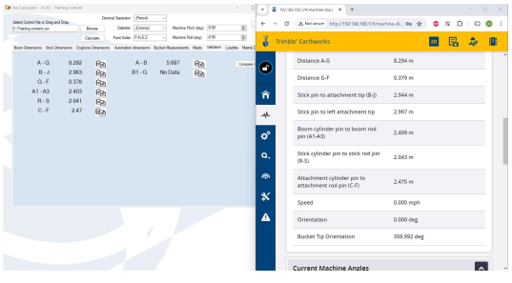
Step 7: Prove the 3D Vector Cal Measure up (without design data)
Within this section of the validation, you will be proving that the points measured up for 3D vector calibration (Mast Measure up) are within specification. This step requires monitoring the bucket tip position in relation to a reference point painted or marked on the ground.
For this step, the machine must have a valid 3D position, which is determined by a UTS or GNSS receiver.
Note: This test requires an accuracy of less than ± 25mm however maximum specification is ± 50mm. This test also requires the machine to be connected to a correction source to complete.
Note: The step can be completed after the machine is fully commissioned and calibrated. These are generally steps that occur on the customer’s site running their design.

1. Place the machine into Position 1 with the bucket tip placed on the reference
point.
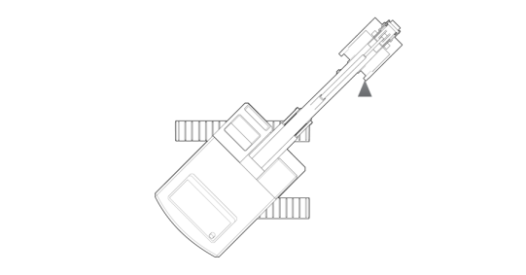
2. Record the Northing, Easting and Elevation of the bucket tip in this position.
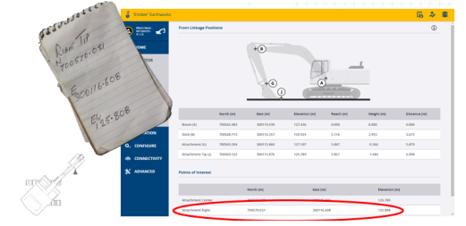
3. Place the machine into Position 2. This should be approximately 90 degrees to
the tracks.
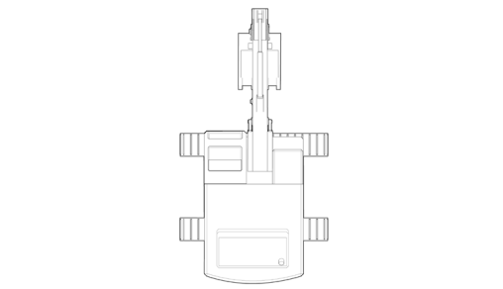
4. Reach out and place the same bucket tip onto the reference point.
5. Record the Northing, Easting and Elevation in Position 2.
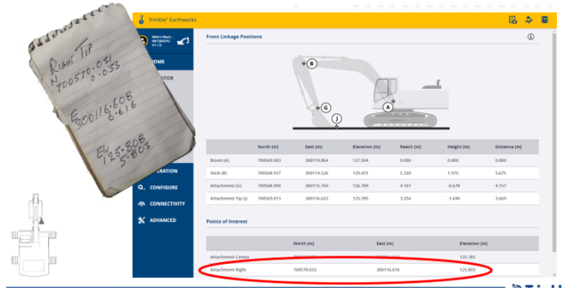
6. Place the machine into Position 3 as shown. The machine should be
approximately 135 degrees to the track.
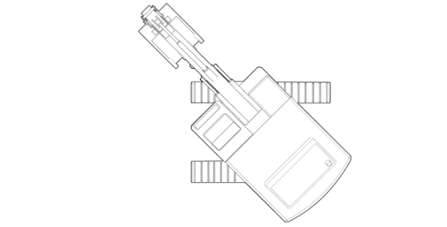
7. Record the Northing, Easting and Elevation of the bucket tip in Position 3.
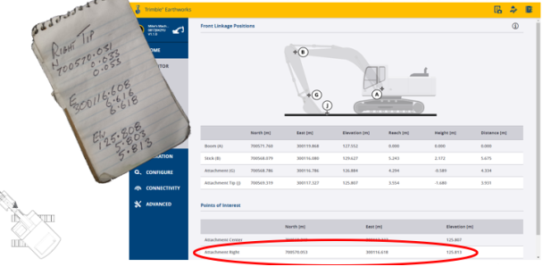
8. If all 3 positions are within ± 50mm for Northing, Easting and Elevation this test
has been passed. Preferred specification is ± 25mm.
Step 8: Prove the 3D Vector Cal Measure up (with design data)
This section of validation is similar to the previous step. The difference being that a site calibration is loaded onto the machine is correct and that the base station position is correct.
It will be required to have the Northing, Easting and Elevation of this point to accurately validate the 3D measure up. It may be necessary to create a simple design utilizing Siteworks if a known point is not available.
Note: This test requires an accuracy of less than ± 25mm however maximum specification is ± 50mm. This test also requires the machine to be connected to a correction source to complete.

1. Ensure that the same design is loaded in both the machine and the data
collector.
2. Place bucket focus point onto the known reference point
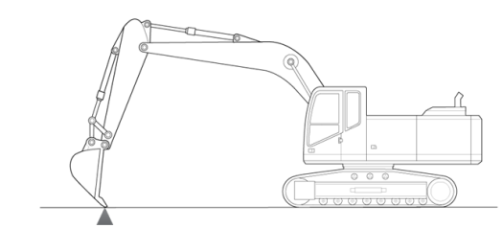
3. Note Northing, Easting and Elevation in 3 different machine positions.
4. Compare the Northing, Easting and Elevations that is reported from Earthworks
in all 3 positions to that of the known point’s coordinates.
Step 9: Prove the Design
Load the customer’s design into the Earthworks system and enter the run screen.
1. Dig to design
2. Have the grade checker or surveyor check the grade of the passes that were just
made.
3. Make sure that the vertical offset is the same for the machine and grade
checker. Using zero is best practice.
4. If the grade check and machine match, the machine is ready for production.

